Teaching Learning Workshop Dated: 22nd February 2020

Title of the method: Demonstration

Concept: A demonstration is an act of showing that something exists or is true by giving proof or evidence. This activity was conducted during a Psychology class for the course titled Cognitive Psychology. The students were required to conduct a practical exhibition and give an explanation of how a concept or a theory works or is performed, based on the topics from the syllabus. For this activity the topics given were ‘Attention’, ‘Memory’ and ‘Perception’.

Objectives:
To help students understand the different concept
To develop presentation skills among students
To instill self confidence in students
To develop creativity in demonstrating an activity
To make learning an enjoyable experience

Procedure: This activity was conducted in class for the course titled ‘Cognitive Psychology’. The course is taught to 40 students, who were put into 8 groups of 5 students each and were given topics for the activity from the syllabus. The topics selected were ‘Attention, Memory and Perception’. These topics were given well in advance so that the students had ample of time to think about which topic they would choose, and how they would conduct the demonstration. Before conducting the activity, a short class was conducted to explain the concepts of the given topics and the study material was also distributed well in advance. Some of the demonstrations conducted by the students, required the participation of only a few volunteers, while other demonstrations required the participation of the entire class. There was no restriction on how many activities were to be conducted on the selected topic. It was observed that groups that were conducting the demonstrations, prepared for the activities utmost dedication and conducted the activities very creatively. It was also observed that the groups presenting, thoroughly enjoyed conducting the activities and gave the explanation for their demonstrations with a lot of confidence. As far as the volunteers and participants were concerned, they were thrilled to be a part of a different learning experience. Below are pictures of students conducting and participating in the demonstrations.
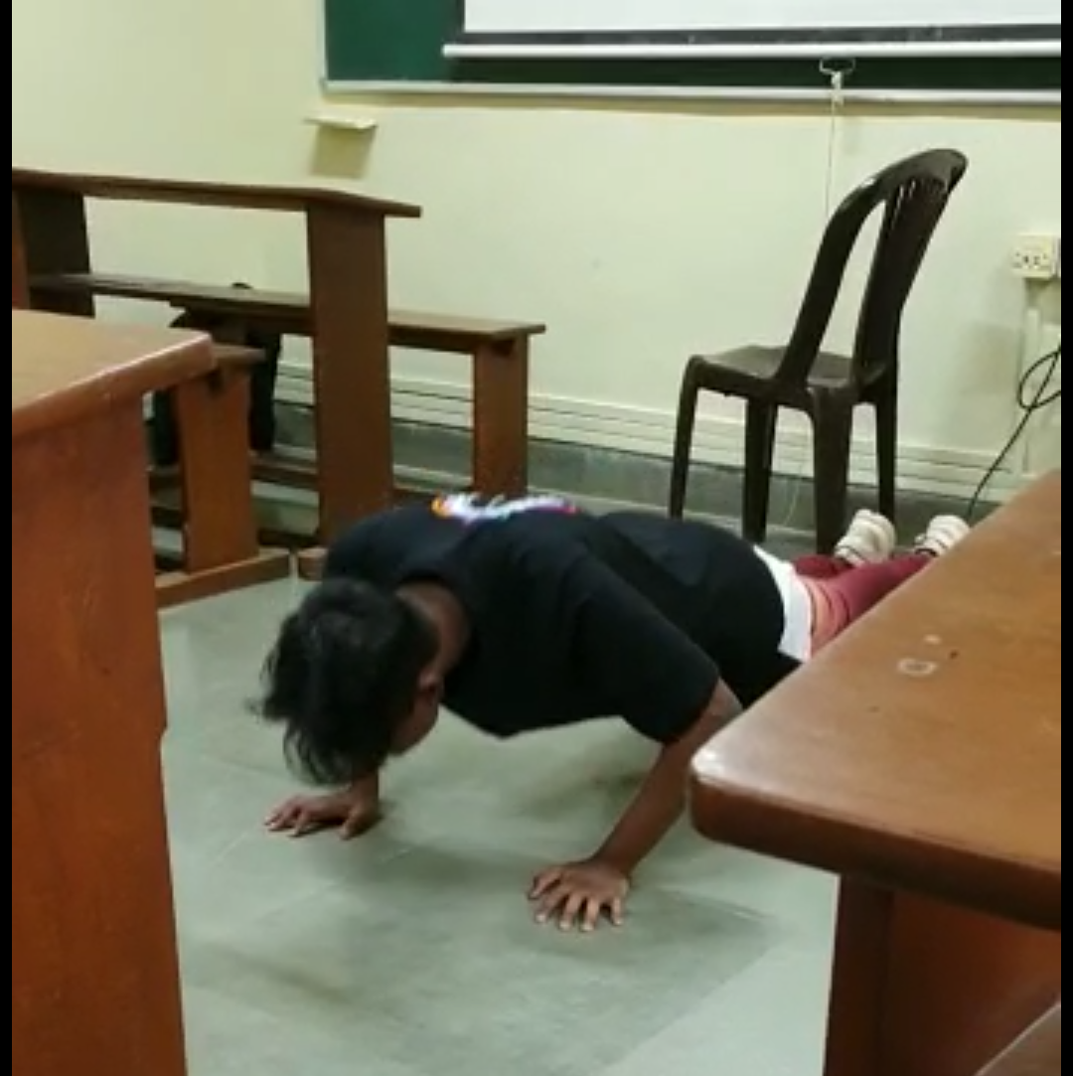
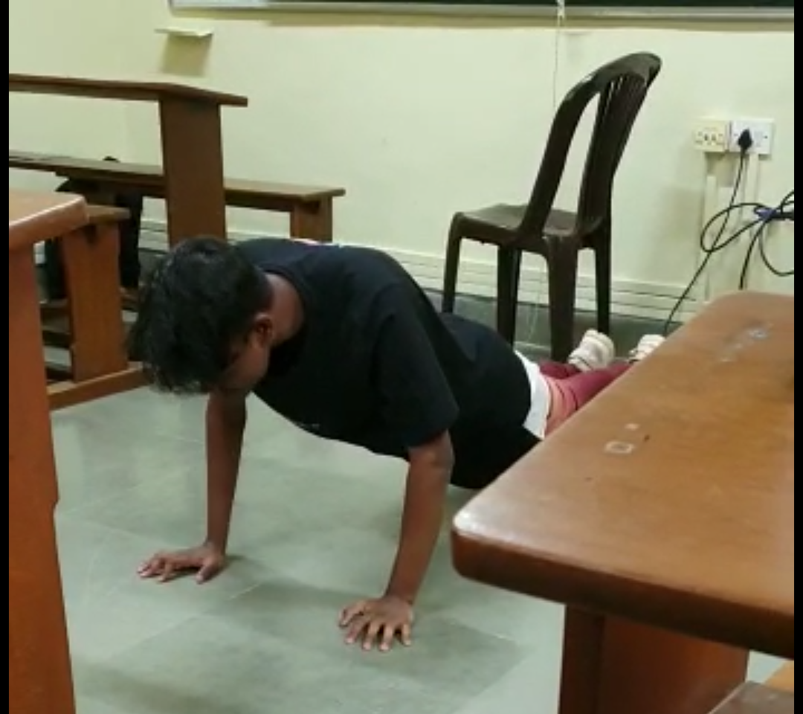

Outcomes: One of the outcomes observed was that, students were able to remember the activity that they participated in, and were able to correctly and aptly explain the concepts related to the activity. Similarly the groups that had conducted the activity, remembered the concepts better. Another outcome observed was that, initially, when the activity started, the presenters seemed to be nervous but, as the demonstrations continued, they appeared to be more confident while presenting. A third outcome observed was that, students seemed reluctant to participate but, upon encouragement, they confidently performed the required tasks. They also seemed less reluctant while doing group tasks rather than individual tasks. A competitive spirit was also observed among the participants. All the students, through feedback said that they had enjoyed the activity on the whole.
Challenges Faced: During the brief feedback session, it came to light that the students found it a little difficult to coordinate with group members they had different time slots when they were available due to the time table. Apart from this students seemed a bit reluctant to participate as individual volunteers. No other factors have been reported as interfering in conducting the said activity.

Activity Prepared and Conducted by-
Dr. Golda Vas
Assistant Professor
Department of Psychology
Parvatibai Chowgule College Of Arts And Science, Autonomous.

